Epsom & Ewell F.C.
20
v
CB Hounslow United
Tuesday, 17th April 2018 – 7.45 p.m.
Good evening and welcome to High Road for our final midweek home League match of the season against CB Hounslow United. We welcome their players, supporters and officials and wish them a safe journey home, as of course we do for our own regular supporters.

Our opponents have not been here since the very start of last season, when they battered us 5-1 in our opening League match back on 16th August. Since then, we returned the favour with a 2-0 win at the Orchard in February 2017 and then had to accept defeat by four goals to two on the opening day of this season when we were the first League visitors to their new ground at The Lair. It is quite some achievement to get a new ground, especially in the South East as we know only too well and I’m sure they will go from strength to strength in the years to come.

But for now, it’s time for us to look at our own fate. We have some bad news and some good news. Firstly, our excellent 2-2 draw against newly crowned Champions Westfield on Saturday has guaranteed that we will finish in the bottom three this season. After many years at the top end of this table watching a number of clubs survive on a regular basis, some may say it is harsh that the first time we are in the relegation area since 2006 we end up dropping down, and whilst that isn’t guaranteed yet, it certainly looks as though the bottom two clubs will drop, most likely us and Farnham Town, with Godalming Town attempting to chase the clubs down that are above them.

Essentially this means that operation Bounceback starts here, although it’s something that the Committee have been preparing for in the last month or two. We believe that our players have potential and if they remain for the next campaign then we have every chance of returning to Step Five in the very near future and that of course is our aim.

The good news is that our new ground proposal is to be discussed by the Residents Association on 14th May. For those who are unaware they are the majority group on the Epsom & Ewell Borough Council, so if we can convince them, we have every chance of moving back to the Borough on a part of the Hook Road Arena. If you personally know any Councillors, please have an off the record chat with them, as this may well be the last card we have to play in our hand.

We have a trip to North Greenford United this Thursday evening and then have the Saturday off before finishing our campaign with a trip to Walton & Hersham at the new Elmbridge Sports Hub on Tuesday 24th April and return here four days later for our final match of the season at home to AFC Hayes, which will also carry the traditional bumper programme, summarising the season’s highlights. For obvious reasons, it might not be as long an article as usual!

Enjoy the game!

Rich

Don’t forget, you can now follow us on Social Media. Please see the inside cover for addresses.

Cover photos by Gemma Jarman

1) Kyen Nicholas scores our first goal at Guildford City on 7th April
2) Marlon Pinder is nearby as Liam Roberts scores our third goal in the same match
1
Cherry Red Records Combined Counties League
Premier Division Table 2017/18
inc Saturday 14th April | P | W | D | L | F | A | Pts | GD | H | A
Westfield | 37 | 33 | 2 | 2 | 137 | 36 | 101 | +101 | 2-2 | 0-5
Bedfont Sports | 38 | 27 | 5 | 6 | 98 | 53 | 86 | +45 | 2-4 | 0-7
Sutton Common Rovers | 38 | 26 | 4 | 8 | 89 | 44 | 82 | +45 | 0-2 | 0-5
Walton & Hersham | 38 | 23 | 6 | 9 | 77 | 48 | 75 | +29 | 0-2 | 24/4
Redhill | 38 | 18 | 5 | 15 | 77 | 60 | 59 | +17 | 0-5 | 0-3
Camberley Town | 39 | 13 | 20 | 6 | 50 | 37 | 59 | +13 | 0-0 | 1-1
Balham | 32 | 16 | 6 | 10 | 66 | 51 | 54 | +15 | 0-2 | 0-4
CB Hounslow United | 34 | 16 | 5 | 13 | 65 | 49 | 53 | +16 | 17/4 | 2-4
Knaphill | 36 | 14 | 11 | 11 | 67 | 59 | 53 | +8 | 0-0 | 2-6
Spelthorne Sports | 40 | 15 | 8 | 17 | 65 | 64 | 53 | +1 | 1-5 | 0-0
Guildford City | 38 | 14 | 7 | 17 | 65 | 80 | 49 | -15 | 1-3 | 3-4
Horley Town | 37 | 14 | 7 | 16 | 55 | 74 | 49 | -19 | 2-3 | 2-3
Hanworth Villa | 36 | 12 | 9 | 15 | 60 | 74 | 45 | -14 | 1-1 | 3-2
Abbey Rangers | 36 | 11 | 10 | 15 | 52 | 56 | 43 | -4 | 1-1 | 0-0
North Greenford United | 32 | 11 | 9 | 12 | 54 | 56 | 42 | -2 | 1-2 | 19/4
Colliers Wood United | 36 | 12 | 4 | 20 | 59 | 65 | 40 | -6 | 0-1 | 2-5
AFC Hayes | 34 | 11 | 6 | 17 | 47 | 67 | 39 | -20 | 28/4 | 0-2
Chertsey Town | 37 | 10 | 6 | 21 | 57 | 82 | 36 | -25 | 2-7 | 0-1
Banstead Athletic | 37 | 9 | 7 | 21 | 46 | 89 | 34 | -43 | 2-2 | 1-1
Godalming Town | 36 | 8 | 6 | 22 | 46 | 81 | 30 | -35 | 0-3 | 2-1
Farnham Town | 39 | 5 | 10 | 24 | 45 | 89 | 25 | -44 | 3-0 | 0-0
Epsom and Ewell | 38 | 3 | 11 | 24 | 36 | 99 | 20 | -63 | X | X

Lucky Day? – 17th April
Played 19 - Won 10 Drawn 4 Lost 5 - For 39 Against 27 - PPG 1.79 - Good
Our Club record against CB Hounslow United
Played 4 - Won 1 Drawn 0 Lost 3 - For 6 Against 11 - PPG 0.75 - Horrible
Largest wins and losses against CB Hounslow United
Tuesday 14th February 2016 - Won 2-0 - Combined Counties League (A)
Tuesday 16th August 2016 - Lost 1-5 - Combined Counties League (H)
CB Hounslow United’s Last Visit
Tuesday 16th August 2016 - Lost 1-5 - Combined Counties League

First Eleven Appearances 2017/18 - (max 44)
Name | Debut | 2017/18 |  |  |  | Career Totals
 |  | App | Sub | Tot | Goals | App | Sub | Tot | Goals
AJAYI Tayo* | 06/08/2017 | 3 | 4 | 7 | 1 | 3 | 4 | 7 | 1
ANDERSON Miguel | 03/02/2018 | 4 | 2 | 6 | 0 | 4 | 2 | 6 | 0
BROOKS Jordan* | 06/08/2017 | 3 | 0 | 3 | 0 | 3 | 0 | 3 | 0
BURROWES Joshua* | 02/12/2017 | 1 | 1 | 2 | 0 | 1 | 1 | 2 | 0
CASTELL Cristian* | 06/08/2017 | 2 | 4 | 6 | 0 | 2 | 4 | 6 | 0
CAULCRICK Joshua | 17/02/2018 | 0 | 1 | 1 | 0 | 0 | 1 | 1 | 0
CLARK Jordan | 17/02/2018 | 0 | 2 | 2 | 0 | 0 | 2 | 2 | 0
CONNELLY Lloyd | 14/10/2017 | 26 | 4 | 30 | 2 | 26 | 4 | 30 | 2
DEWAR Ali* | 29/10/2011 | 1 | 2 | 3 | 0 | 56 | 42 | 98 | 10
DOBRAJ Endrit | 18/11/2017 | 17 | 3 | 20 | 0 | 17 | 3 | 20 | 0
DYSON Ben | 12/08/2017 | 27 | 10 | 37 | 2 | 27 | 10 | 37 | 2
FRANKLIN Ben | 03/03/2015 | 3 | 1 | 4 | 0 | 4 | 1 | 5 | 0
GRAHAM Bentley* | 09/02/2016 | 3 | 0 | 3 | 0 | 20 | 1 | 21 | 3
GRANDISON Kane* | 11/11/2017 | 7 | 1 | 8 | 0 | 7 | 1 | 8 | 0
GRIFFIN Reisse | 08/08/2015 | 27 | 0 | 27 | 2 | 100 | 13 | 113 | 8
HARLAND-GODDARD Tom* | 06/08/2017 | 1 | 1 | 2 | 0 | 1 | 1 | 2 | 0
HARRIS Colin* | 04/08/2012 | 9 | 0 | 9 | 0 | 34 | 0 | 34 | 0
HATFIELD Jamie* | 11/11/2006 | 9 | 1 | 10 | 0 | 258 | 14 | 272 | 6
HAYWARD Ben* | 07/03/2007 | 5 | 1 | 6 | 0 | 248 | 29 | 277 | 18
HEAGNEY Adam | 16/08/2016 | 27 | 3 | 30 | 0 | 64 | 12 | 76 | 1
HENDRY Rob* | 08/08/2015 | 16 | 1 | 17 | 5 | 84 | 23 | 107 | 28
HOUGH Kyle* | 14/08/2007 | 10 | 2 | 12 | 6 | 343 | 21 | 364 | 207
JASPER Joe* | 11/11/2017 | 0 | 1 | 1 | 0 | 0 | 1 | 1 | 0
JEANNOEL Germaine | 02/12/2017 | 2 | 7 | 9 | 1 | 2 | 7 | 9 | 1
KENNEDY Calum | 18/11/2017 | 2 | 1 | 3 | 0 | 2 | 1 | 3 | 0
LAW Franky* | 06/08/2017 | 3 | 0 | 3 | 0 | 3 | 0 | 3 | 0
LOFTUS-CHEEK Joe | 06/08/2017 | 11 | 7 | 18 | 4 | 11 | 7 | 18 | 4
MACAULEY Alvin | 10/03/2018 | 0 | 2 | 2 | 0 | 0 | 2 | 2 | 0
MARKS Samuel* | 06/01/2018 | 1 | 2 | 3 | 0 | 1 | 2 | 3 | 0
MARVELL Dale* | 15/01/2000 | 17 | 2 | 19 | 0 | 286 | 51 | 337 | 86
MASTERSON Shaun | 25/11/2017 | 7 | 3 | 10 | 0 | 7 | 3 | 10 | 0
MCKAY Alex | 20/12/2008 | 28 | 1 | 29 | 1 | 159 | 38 | 197 | 13
MULLINGS Corey* | 23/12/2017 | 0 | 2 | 2 | 0 | 0 | 2 | 2 | 0
MURPHY George | 19/03/2013 | 2 | 0 | 2 | 0 | 70 | 7 | 77 | 3
MURPHY Scott | 20/01/2007 | 31 | 0 | 31 | 2 | 43 | 2 | 45 | 3
MYERS Antony* | 23/12/2006 | 1 | 0 | 1 | 0 | 76 | 33 | 109 | 9
NICHOLAS Kyen | 13/01/2018 | 10 | 2 | 12 | 6 | 10 | 2 | 12 | 6
NWACHUKWU Jason* | 01/10/2016 | 9 | 4 | 13 | 2 | 26 | 20 | 46 | 3
O'BRIEN Louis | 28/08/2017 | 3 | 6 | 9 | 0 | 3 | 6 | 9 | 0
PINDER Marlon | 13/01/2018 | 10 | 1 | 11 | 1 | 10 | 1 | 11 | 1
ROBERTS Liam | 12/08/2017 | 21 | 10 | 31 | 5 | 21 | 10 | 31 | 5
ROBINSON Sam* | 22/10/2011 | 5 | 0 | 5 | 0 | 66 | 6 | 72 | 14
ROSE Daniel* | 25/10/2016 | 14 | 2 | 16 | 1 | 16 | 7 | 23 | 1
RUSSELL Stuart | 30/03/2018 | 1 | 1 | 2 | 0 | 1 | 1 | 2 | 0
SAMPAT Mohammed* | 23/12/2017 | 3 | 0 | 3 | 0 | 3 | 0 | 3 | 0
SELLICK Rory | 27/01/2018 | 6 | 0 | 6 | 1 | 6 | 0 | 6 | 1
SMITH Andy* | 25/08/2017 | 2 | 0 | 2 | 0 | 2 | 0 | 2 | 0
SMITH Taryn | 28/10/2017 | 7 | 4 | 11 | 0 | 7 | 4 | 11 | 0
STEW-LEWIS Noah | 09/12/2017 | 6 | 2 | 8 | 0 | 6 | 2 | 8 | 0
THOMPSON Ashley | 21/08/2017 | 32 | 1 | 33 | 4 | 32 | 1 | 33 | 4
THOMPSON Elliott | 09/02/2016 | 3 | 0 | 3 | 0 | 10 | 9 | 19 | 1
THOMSON David* | 02/09/2017 | 2 | 2 | 4 | 0 | 2 | 2 | 4 | 0
TURPIE Ali | 31/03/2016 | 1 | 0 | 1 | 0 | 12 | 1 | 13 | 0
WHITE Sean | 02/08/2014 | 14 | 7 | 21 | 2 | 20 | 20 | 40 | 5
YOUNG Conor | 07/03/2015 | 29 | 0 | 29 | 0 | 30 | 0 | 30 | 0

Recent Results and Fixtures
Combined Counties League – Thursday 12th April 2018
Balham | 3-0 | Farnham Town
Banstead Athletic | 2-0 | Balham
Redhill | 4-1 | AFC Hayes
Westfield | 4-1 | Knaphill
Combined Counties League – Friday 13th April 2018
Colliers Wood United | 1-2 | Walton & Hersham
Combined Counties League – Saturday 14th April 2018
Abbey Rangers | 0-3 | Redhill
Bedfont Sports | 5-0 | Banstead Athletic
Camberley Town | 0-1 | AFC Hayes
Epsom & Ewell | 2-2 | Westfield
Farnham Town | 1-2 | Guildford City
Godalming Town | 3-6 | Sutton Common Rovers
Horley Town | 2-4 | CB Hounslow United
Knaphill | 4-1 | Chertsey Town
North Greenford United | 2-2 | Balham
Spelthorne Sports | 1-4 | Hanworth Villa
Combined Counties League – Tuesday 17th April 2018
AFC Hayes | V | Chertsey Town
Banstead Athletic | V | Redhill
Epsom & Ewell | V | CB Hounslow United
Hanworth Villa | V | Godalming Town
Knaphill | V | Guildford City
North Greenford United | V | Abbey Rangers
Westfield | V | Balham
Combined Counties League – Wednesday 18th April 2018
Colliers Wood United | V | Horley Town
Combined Counties League – Thursday 19th April 2018
Balham | V | Hanworth Villa
North Greenford United | V | Epsom & Ewell
Combined Counties League – Saturday 21st April 2018
AFC Hayes | V | Walton & Hersham
Balham | V | Camberley Town
Recent Results and Fixtures
Combined Counties League – Saturday 21st April 2018
Banstead Athletic | V | Farnham Town
CB Hounslow United | V | Colliers Wood United
Chertsey Town | V | Horley Town
Guildford City | V | Spelthorne Sports
Hanworth Villa | V | Abbey Rangers
Redhill | V | Knaphill
Sutton Common Rovers | V | North Greenford United
Westfield | V | Bedfont Sports
Combined Counties League – Monday 23rd April 2018
Balham | V | North Greenford United
Combined Counties League – Tuesday 24th April 2018
AFC Hayes | V | Bedfont Sports
Camberley Town | V | Westfield
CB Hounslow United | V | Farnham Town
Knaphill | V | Hanworth Villa
Redhill | V | Horley Town
Walton & Hersham | V | Epsom & Ewell
Combined Counties League – Wednesday 25th April 2018
Balham | V | Colliers Wood United
Guildford City | V | North Greenford United
Combined Counties League – Thursday 26th April 2018
AFC Hayes | V | Abbey Rangers
Combined Counties League – Saturday 28th April 2018
Abbey Rangers | V | Westfield
Bedfont Sports | V | Walton & Hersham
Camberley Town | V | Redhill
Colliers Wood United | V | Banstead Athletic
Epsom & Ewell | V | AFC Hayes
Farnham Town | V | Balham
Godalming Town | V | Hanworth Villa
Horley Town | V | Sutton Common Rovers
North Greenford United | V | Chertsey Town
Spelthorne Sports | V | CB Hounslow United

From behind the goal
Epsom & Ewell 2-2 Westfield
Combined Counties League - Premier Division - Saturday 14th April 2018

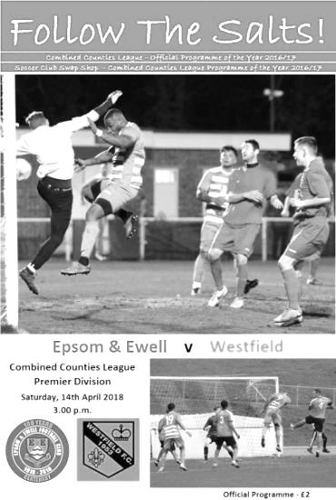
Moral victory for the Salts

Cast your mind back to 25th November 2017. That's quite a long time ago, yet that was the last time Westfield failed to secure three points from a Combined Counties League fixture, losing 3-1 to Redhill. They have recorded Seventeen straight wins from that date, so much credit is due to our team for holding the newly crowned Champions to a draw at High Road. Throw in the fact that we were somewhat harshly two goals down at half time and this is arguably the result of the season.

Westfield apparently made five changes from their team that clinched the league title against Knaphill two days previously, but we were also missing our Captain Alex McKay and also our two goal hero from last week's narrow defeat at Guildford City, Kyen Nicholas. Adam Heagney slotted in at the back, while up front Joe Loftus-Cheek had his first start since November. Ashley Thompson and Reisse Griffin also returned after missing last week's match and they came in for the absent Elliott Thompson and Shaun Masterson.

We started brightly against the visitors, maybe with a nothing to lose mentality, but either way we nearly took the lead in the second minute when an Adam Heagney free kick was met by a Loftus-Cheek header from ten yards that just went beyond the left hand post of Westfield custodian Gary Ross. We nearly got through again after Loftus-Cheek turned provider and his deep cross was headed back across goal by Marlon Pinder, playing in a more central attacking role than usual, but his header was just too high for the incoming Ben Dyson to reach.

Inevitably Westfield got into the match and the dangerous Aaron Watson got away on the left and rounded Heagney, but was pushed wide in the process and his low shot only found the side netting. In the 9th minute Conor Young saw his first action as he reacted well to save a snap shot on the turn from close range and then made a second save when it appeared that the loose ball seemed certain to go in.

Young was busy again in the 18th minute when a swerving long range effort deceived him and he was unable to hold the ball, but recovered quickly to block the follow-up for a corner. Unfortunately we conceded in the 33rd minute and it was hard to see exactly what happened from my vantage point. What I could see was an under hit back pass which was intercepted and Young saved the subsequent shot, but it appeared to be

forced in by Watson for their opening goal.

Almost immediately we could and maybe should have been level as an Epsom corner was delivered to the far post where Griffin had got forward and leapt to head the ball at goal, but having done the hard work to get there he was unable to get a full contact and the header went wide of the post. We nearly paid for it straight away as Watson combined with Jamie Okai who sent a dangerous low shot just beyond our far post, but having dodged that bullet we were really unfortunate to go further behind in the 43rd minute when Watson appeared to send a cross in from the left which found the top corner of the goal from fully thirty yards.

The half time score was harsh but we were back in the match early in the second half. A deep 52nd minute free kick from Heagney reached Louis O'Brien at the far post and he delivered a superb low ball in across the six yard box where Loftus-Cheek was waiting to pounce, giving Ross no chance. We nearly equalised three minutes later when the ball came in from the right to Loftus-Cheek who then stumbled, but this seemed to freeze the defence momentarily and Pinder nipped in, although Ross blocked his shot from close range and then gathered the loose ball for good measure.

The visitors were still dangerous of course, and some good interplay between Okai and Watson led to the latter firing over from close range after 65 minutes but we were soon on the attack again and this time would get our reward. Another Heagney free kick was headed clear but Pinder was first to the loose ball and he hooked it back in quickly. Two Westfield defenders went for the ball and got in the way of each other, and for what seemed like the first time in weeks, the loose ball actually fell kindly for one of our players and Loftus-Cheek scored his second goal from twelve yards low past an unsighted Ross with the clock showing the 70th minute.

The game remained even and we had a great opportunity to go ahead in the 83rd minute when the ball went under Leavan Sullivan's foot, leaving Loftus-Cheek through on goal and his shot was going just inside the right hand post, but Ross made an extremely good save with his right shin to deflect the shot around the post. We then had a couple of scares at the other end as the visitors pushed for a winner, but the first was foiled by a superb crunching tackle from Lloyd Connelly, while the second effort fizzed from right to left across our goalmouth and just beyond our far post.

We have produced two fine performances in recent weeks against Bedfont Sports and now Westfield, and can certainly claim a moral victory, in addition to becoming the first team to take a point off them in five months. There was another small issue to report, as the draw confirmed that we are now mathematically unable to escape the bottom three in the table and the likely relegation it will bring, but in all fairness that has appeared inevitable for some time and the fact that it actually happened as a result of this fine draw is almost an irrelevance. If we can perform like this on a regular basis we will surely be returning to Step Five very rapidly.

Epsom and Ewell: Conor Young, Endrit Dobraj, Reisse Griffin, Lloyd Connelly, Adam Heagney, Ashley Thompson (c), Ben Dyson, Scott Murphy, Joe Loftus-Cheek, Marlon Pinder, Louis O'Brien

Subs: Taryn Smith for O'Brien (59), Germaine Jeannoel for Loftus-Cheek (86)

Club Records - 17th April
Date | Day | Competition |  | Opponents |  | Scorers
17/04/26 | Sat | Surrey Senior League | H | Camberley & Yorktown | 5-0 | R.Marlow (4), R.Sperring (pen)
17/04/33 | Mon | London League | H | Tooting & Mitcham | 3-0 | T.Dunne (2), L.Marlow (pen)
17/04/37 | Sat | London League | H | Finchley | 1-1 | A.Griffiths
17/04/48 | Sat | London League | A | Dartford Reserves | 3-2 | L.Gilbert (2), B.Peacock
17/04/54 | Sat | Corinthian League | H | Erith & Belvedere | 3-2 | R.Holloway (2), B.Canham
17/04/57 | Wed | Corinthian League | A | Wembley | 3-0 | R.Colfar, J.Bangs, D.Hermitage
17/04/65 | Sat | Athenian League 1 | H | Hertford Town | 4-1 | S.Dunwoody (2), J.O'Shea, D.Bruce
17/04/69 | Thur | Athenian League 2 | A | Herne Bay | 1-4 | K.Jolly
17/04/71 | Sat | Athenian League 2 | H | Hemel Hempstead Town | 3-1 | G.Marchesi, J.Honeywood, G.Carter
17/04/76 | Sat | Athenian League 2 | H | Uxbridge | 2-0 | J.Eales, P.Butler
17/04/82 | Sat | Isthmian League 1 | A | Oxford City | 1-1 | A.Ives
17/04/93 | Sat | Isthmian League 3 | H | Aldershot Town | 1-2 | R.Purvis
17/04/95 | Mon | Isthmian League 3 | H | Feltham & Hounslow Borough | 1-1 | R.Dymond
17/04/99 | Sat | Isthmian League 3 | H | Aveley | 1-0 | J.Hall
17/04/04 | Sat | Isthmian League 1s | A | Bracknell Town | 0-2
17/04/06 | Mon | Isthmian League 2 | A | Dorking | 3-4 | C.Heuston (2), D.Marvell (pen)
17/04/07 | Tue | Combined Counties  Premier Division | H | Merstham | 0-3
17/04/10 | Sat | Combined Counties  Premier Division | H | Badshot Lea | 2-2 | R.Burns, K.Hough
17/04/17 | Mon | Combined Counties  Premier Division | A | Horley Town | 2-1 | R.Hendry, M.Ferdinando
Historical Decades
90 years ago – Epsom Town F.C.
21/04/28 | Sat | London League | A | Carshalton Athletic | 1-2 | R.Marlow
80 years ago – Epsom F.C.
16/04/38 | Sat | London League | H | Wandsworth United | 6-1 | B.Solly (3), H.Pullen, J.Jones, G.Collins
70 years ago – Epsom F.C.
17/04/48 | Sat | London League | A | Dartford Reserves | 3-2 | L.Gilbert (2), B.Peacock
60 years ago – Epsom F.C.
19/04/58 | Sat | Corinthian League | H | Yiewsley | 3-2 | D.Hermitage (2), K.Harris
50 years ago – Epsom & Ewell F.C.
15/04/68 | Mon | Athenian League 2 | A | Uxbridge | 2-1 | T.Yorke, A.Parrott
40 years ago – Epsom & Ewell F.C.
18/04/78 | Tue | Isthmian League 2 | A | Cheshunt | 1-2 | G.Archer
30 years ago – Epsom & Ewell F.C.
16/04/88 | Sat | Isthmian League 2s | A | Chalfont St Peter | 2-0 | L.Harding, B.Perkins
20 years ago – Epsom & Ewell F.C.
18/04/98 | Sat | Isthmian League 3 | H | Lewes | 4-0 | S.Smith (pen), P.Bunter, A.Nimmo, A.Boxall
10 years ago – Epsom & Ewell F.C.
19/04/08 | Sat | Combined Counties  Premier Division | H | North Greenford United | 3-0 | K.Hough (pen), R.Burns (2)

History Corner – 17th April
92 years ago today we were on the brink of wrapping up our first ever Surrey Senior League title and dispatched Camberley & Yorktown as they were then known, by five clear goals at West Street with Reg Marlow netting four of them. The title would be confirmed a week later.
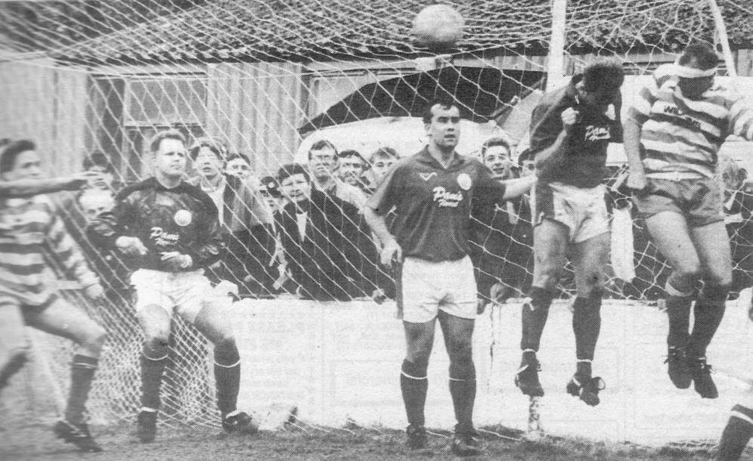
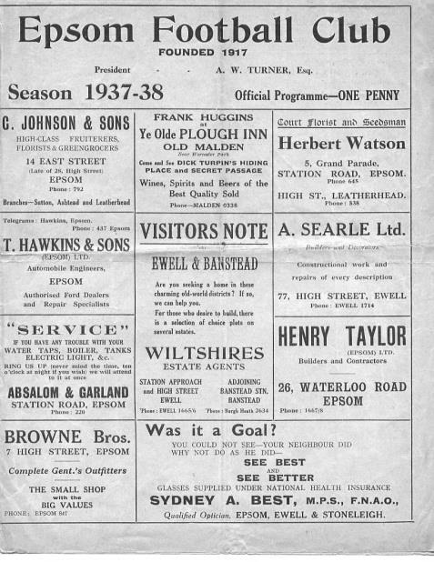
80 years ago this week we played host to Wandsworth and battered them 6-1 in a London League match (see programme) Basil Solly scored three goals for us this day. He had formerly been at Sutton and when he left, some Sutton fans came to watch our match instead of their own one, such was their disappointment at losing the player! Basil’s older brother also played in goal for Dulwich Hamlet during the early thirties.

53 years ago today we defeated Hertford Town in an important League relegation battle. Steve Dunwoody scored twice along with John O’Shea and Don Bruce, but it would be the return match two weeks later when the controversy would descend as we would win there, only to then be found guilty of playing an ineligible player and the points deducted (and subsequent £5 fine) ensured our club’s first ever relegation.

25 years ago today we played our last ever League match at West Street as we met the Division Three Champions Aldershot Town. Just over 1,000 were present to watch the first half end goalless before the visitors scored twice in the second half, although our late consolation from Ray Purvis was the final Isthmian League goal scored at the venue. The picture below shows Richard Strong flicking on the corner for Ray Purvis to head in from close range at the clubhouse end.

Centre page for results

Centre page for results

Buildbase F.A. Vase
Fifth Round – 3rd February
Wolverhampton SC | 3-4 | Leighton Town
Thatcham Town | 2-1 | Bromsgrove Sporting
Marske United | 2-0 | Bradford Town
Coleshill Town | 2-4+ | Bracknell Town
1874 Northwich | 1-0 | Chichester City
Stockton Town | 3-0 | Stourport Swifts
Windsor | 2-0 | Hamble Club
Melksham Town | 2-1 | Tring Athletic
Quarter-Finals – 24th February
Bracknell Town | 0-3 | Marske United
Melksham Town | 0-1 | Thatcham Town
Stockton Town | 2-0 | Windsor
Leighton Town | 0-1 | 1874 Northwich
Semi-Finals – 17th March & 24th March – two legs
Stockton Town | 2-0 – 1-2 | Marske United
Thatcham Town | 1-0 – 3-2 | 1874 Northwich

Combined Counties League Cup
Quarter-Finals
Godalming Town | 0-2 | Knaphill
Spelthorne Sports | 1-3 | Walton & Hersham
Sutton Common Rovers | 2-1 | Cobham
Worcester Park | 5-2 | Colliers Wood United
Semi-Finals
Worcester Park | 3-2 | Sutton Common Rovers
Walton & Hersham | 1-2 | Knaphill

Surrey Senior Cup
Second Round
Leatherhead | 2-0 | Kingstonian
Epsom & Ewell | 0-5 | Merstham
Farnham Town | 0-3 | Met Police
Westfield | 2-3 | Colliers Wood United
Spelthorne Sports | 0-4 | South Park
Sutton United | 7-1 | Molesey
Chipstead | 3-2 | Tooting & Mitcham United
Dorking Wanderers | 2-1 | Carshalton Athletic
Quarter-Finals
Met Police | 1-1 - (2-4p) | Leatherhead
Colliers Wood United | 0-6 | Dorking Wanderers
Sutton United | 1-2 | Merstham
Chipstead | 0-1 | South Park
Semi-Finals
Dorking Wanderers | 0-1 | Leatherhead
Merstham | 6-0 | South Park

CB Hounslow United – History
CB Hounslow United F.C is a Football club based in the London Borough of Hounslow. The team was originally named Richmond Rangers, and was a collection of friends and local troubled youth. In season 1987/88 it was disbanded and reformed in 1988/89 under the name of CB united.

CB stands for ‘Cater Bank’ which was the company co-owned by the late father of our current chairman Frank James. CB Hounslow played in the Hounslow & District Football League with some distinction, and after 5 successful years we were promoted to the Middlesex county Football League (MCFL) in 1994/95 . That’s when we then took our present name CB Hounslow United.

CB Hounslow United played for 11 years in the MCFL before being promoted to the Combined Counties in 2005/6 season. The club is now affiliated to the Combined Counties League, Middlesex County FL, West Middlesex Sunday League, Allied Counties Youth League, Surrey Youth League, West Middlesex Youth League and Harrow Youth League and CGL.

The club this year is a good position with 22 youth sides and 12 adult sides from 18 years upwards.

The club this season will be competing in The FA Cup, The FA Vase, The FA Youth Cup and The Help for Heroes Senior Cup amongst many other Cups.

This season sees the opening of our new ground (The Lair) at Green Lane, Hounslow, Middlesex. After 17 years of negotiating and raising funds the club are very proud of what we have achieved with this ground and hope to bring success at the ground.

This year also sees the start of our very own college programme, where once again we hope to be helping out youngsters less fortunate than others.

As always I would like to thank our numerous sponsors, who donate to the youth teams and the main body of the club and also help greatly with the fundraising for the build of the new ground. The club continues to grow its partnership with DNATA & London Borough of Hounslow Council.

Finally, we have over 50 volunteers who make up our management, coaching and secretarial staff who without them the club wouldn’t be where it is now.

Combined Counties League Premier Division
Opponents All-time Records
inc Saturday  14th April | P | W | D | L | F | A | PPG | GD | Best  Win | Worst  Loss
Horley Town | 32 | 21 | 5 | 6 | 71 | 37 | 2.13 | +34 | 6-0 | 1-3
Sutton Common Rovers* | 15 | 9 | 3 | 3 | 30 | 21 | 2.00 | +9 | 4-0 | 0-5
Spelthorne Sports* | 9 | 5 | 3 | 1 | 16 | 11 | 2.00 | +5 | 6-2 | 1-5
Godalming Town | 3 | 2 | 0 | 1 | 4 | 5 | 2.00 | -1 | 2-1 | 0-3
Banstead Athletic | 39 | 23 | 8 | 8 | 64 | 40 | 1.97 | +24 | 5-0 | 0-4
Abbey Rangers | 6 | 3 | 2 | 1 | 12 | 5 | 1.83 | +7 | 7-1 | 2-3
Farnham Town | 17 | 9 | 4 | 4 | 30 | 25 | 1.82 | +5 | 3-0 | 1-4
Bedfont Sports | 13 | 7 | 2 | 4 | 23 | 23 | 1.77 | 0 | 5-1 | 0-7
Colliers Wood United | 25 | 14 | 2 | 9 | 47 | 40 | 1.76 | +7 | 4-0 | 0-5
Westfield | 23 | 12 | 4 | 7 | 43 | 41 | 1.74 | +2 | 6-1 | 0-5
Guildford City | 20 | 11 | 1 | 8 | 39 | 29 | 1.70 | +10 | 5-1 | 1-5
Knaphill | 10 | 5 | 2 | 3 | 20 | 16 | 1.70 | +4 | 4-0 | 2-6
Hanworth Villa | 19 | 9 | 5 | 5 | 42 | 30 | 1.68 | +12 | 5-0 | 1-4
Walton & Hersham | 53 | 25 | 11 | 17 | 105 | 101 | 1.62 | +4 | 8-0 | 1-9
Camberley Town** | 92 | 38 | 24 | 29 | 159 | 126 | 1.50 | +33 | 9-1 | 0-4
Redhill | 35 | 14 | 2 | 19 | 63 | 77 | 1.26 | -14 | 7-2 | 2-8
Chertsey Town | 51 | 19 | 5 | 27 | 77 | 95 | 1.22 | -18 | 3-0 | 0-7
North Greenford United | 13 | 4 | 2 | 7 | 19 | 24 | 1.08 | -5 | 3-0 | 1-4
AFC Hayes | 11 | 2 | 3 | 6 | 18 | 20 | 0.82 | -2 | 7-0 | 0-3
CB Hounslow United | 4 | 1 | 0 | 3 | 6 | 11 | 0.75 | -5 | 2-0 | 1-5
Balham | 2 | 0 | 0 | 2 | 0 | 6 | 0.00 | -4 | x | 0-4
* includes one loss on penalties v Spelthorne and one win on penalties v Sutton Common Rovers
** includes one abandoned match v Camberley

Every Opponent A-Z
Over the years we have played many, many different opponents. Exactly how many is a difficult question, as it all depends on your definition. Are Camberley & Yorktown different to Camberley Town, or are Epsom Town different to Epsom F.C. or Epsom & Ewell F.C.?

In my analysis I have classed them as the same team, and will work through them all from A to Z. Some we have played many times, whilst others we have met maybe just once or twice. Enjoy!

Worcester Park: Played 12 - W7 D1 L4 - F34 A23 - PPG - 1.83 - Good

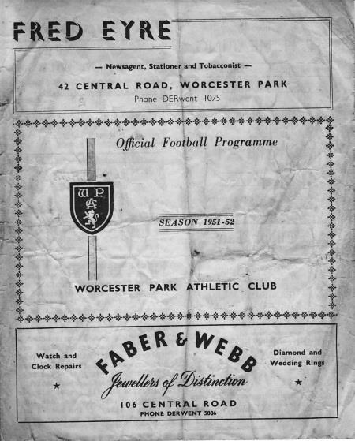
The Worcester Park story is a strange one really. Established around the turn of the Century, they moved to their current venue, Skinners Field in 1921 and joined the Surrey Senior League in its first season after World War Two, 1946/47.

We met them for the first time in a couple of Challenge friendly matches, losing 5-2 at West Street in May 1948 but winning 6-1 on Christmas Day that same year.

Our first cup meeting came on 27th October 1951 when we were paired together in a Surrey Senior Cup tie, winning 4-2 (see programme left).

Our next match provided an embarrassing result in the Third Qualifying Round of the Amateur Cup when we hosted them but lost 2-0 in the infamous “hole in the net” game (their second goal entered the net through a gap in the side netting) The first goal was reportedly offside too but the visitors were the better side and the papers were extremely critical with the Advertiser calling it “the biggest upset in Amateur local soccer this season so far”. The Herald was even more scathing, advising that an obituary notice ought to be published in our next programme reading "Epsom football died here and the Ashes will be taken to Worcester Park"! And people think I’m harsh at times!

We restored order a bit with four wins over the next decade, two in the Amateur Cup and two in the Surrey Senior Cup, all without conceding as they remained a competitive but weakening club. Then at the end of 1962/63 they actually folded! Even their own club history doesn’t report this, but in the summer of 1963 a local club Coombe Sports took over the Worcester Park name and they consolidated in the Sutton & District League. They remained at Intermediate level for many years until rejoining the same league, now known as the Combined Counties League when it expanded to open a second division in 2003.

They met us for the first time in 48 years at Moatside, home of Merstham FC as we were paired together in the League Cup in October 2010 and required our first ever competitive penalty shoot-out win to achieve progress after a 2-2 draw (after extra time). Worse followed as they defeated us 4-1 at Skinners Field in January 2012, although we returned the favour on our next visit in 2016/17 with a 6-3 win in which Daryl Cooper-Smith scored four times for us. As we all know though, they knocked us out of the same cup this season by four goals to two and are now in the Final!

In their time back in our league they have finished in the top half on every season with exception of 2012/13 and 2013/14 when they finished one place below midtable. However, ground issues have led to them being refused promotion in 2009/10 and again the following season when they won the title. Of course, they are likely to win the title once more this season but instead of being promoted, relegation is to be their fate, due to the F.A. restructuring. It is easy to have sympathy with them, but their ground (clubhouse aside) really is a basic one, and many other clubs have had to spend money to stay up so it could be argued that it was money wasted by those clubs if the Park were to stay up again. We may not see them again at this level, which is a pity.

Worthing: Held over to next issue

Wycombe Wanderers: Played 3 W0 D1 L2 F3 A9 - PPG 0.33 - Horrible

Loakes Park, home of Wycombe Wanderers is my favourite football venue of all time. This ground is now long gone and is replaced by housing and a car park near Wycombe Hospital, although old railings still remain, but it was the famous home of a very special club for almost a Century.

They won the Amateur Cup in 1931 and the following season our 4-2 win over Ipswich Town had earned us a tie in the last 32 of the same competition against the Isthmian giants in front of 7,000, although we were crushed 7-2 in the end. We then met on two more occasions in the Isthmian League Premier Division following our promotion in 1984, drawing 0-0 at Loakes Park on 28th August 1984 and narrowly losing 2-1 on their only visit to West Street on 9th March 1985.

The club took a step up to the Alliance Premier League (nowadays the National League) the following season and although they came straight back down, we had also been relegated and so we never met again. Sadly they left Loakes Park in 1990 for the out of town Adams Park, named after the former player who had actually bought the old ground and donated it back to them.

The ground had an incredible slope on it. People say that West Street had a big slope with a nine foot drop from top to bottom, but theirs was eleven feet from side to side!! I went back a few months after they had vacated the ground and strolled across the pitch with the grass up to almost a metre in depth! At one end was a car park which was built as an extension to the hospital, but the other end still had the goalposts up and the terracing behind it! A very sad end to an incredible, quaint and quirky ground, but on balance it was the right move for the club who are of course an established League side these days after Martin O’Neill took them up in the mid-nineties.

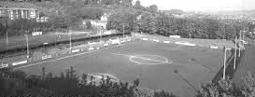
The famous and wonderful Loakes Park with grandstand on the left and a full length covered terrace on the right. This picture was one of the last taken at the ground in 1990 and when I visited once again later that year it was the near end that had been converted into the car park.

Match and Ball Sponsorships – 2017/18
Opponent | Date | Match Sponsor | Ball Sponsor
Banstead Athletic (FAC) | 06/08/17 | Club President - Stella Lamont
Chertsey Town | 15/08/17 | EEFC Management Committee
Redhill | 02/09/17 | Building Shop Ltd
Spelthorne Sports | 09/09/17 | In memory of Betty Dyke
Horley Town | 12/09/17 | Alex McKay (Senior)
Hanworth Villa | 23/09/17 | Jack Jarman
North Greenford United | 28/10/17 | Marvin and Kathy Hough
Farnham Town | 14/11/17 | In memory of Dave and Lizzie Marshall
Godalming Town | 21/11/17 | Building Shop Ltd
Guildford City | 02/12/17 | John Bonner
Walton & Hersham | 30/12/17 | Jeff and Arnold Pye
Merstham (SSC) | 16/01/18 | Paul Merritt
Abbey Rangers | 23/01/18 | Pete Beddoe’s grandchildren  George, Joseph, Ezara & Inaya
Sutton Common Rovers | 03/02/18 | David Ellins
Knaphill | 24/02/18 | Jack Jarman
Camberley Town | 10/03/18 | Pete Lumm
Balham | 13/03/18
Bedfont Sports | 24/03/18 | EEFC Management Committee
Colliers Wood United | 30/03/18
Banstead Athletic | 02/04/18 | Nathan Lambert – 10 years old today!
Westfield | 14/04/18
CB Hounslow United | 17/04/18
AFC Hayes | 28/04/18 | Club President - Stella Lamont
Match sponsorship costs just £60.00!

Sponsorship includes:

Admission, programmes and hospitality for three people.

A full page advert in the programme and mascot for the day (if required).

Also, you get to choose the player of the match, who will receive a prize

If you are interested, just speak to a Committee Member,
or drop me an email at: richard.c.lambert@gmail.com

Salts Super Six Predictor
The Salts Super Six Predictor jackpot was claimed at the last match and now resets at £100 for today’s match. The tickets are on sale to the left of the gate and the matches on the ticket are to be played on Saturday!

The competition is easy to play! To win, you simply need to predict the results of six matches correctly from the three options, fill in the form and make sure it is back with our seller before the deadline on the ticket. The latest fixtures are shown below.

If you are a club regular, you just need to place your name on the sheet, although if you aren’t, then we’ll need a contact number from you too. We will announce any winners on the website within three working days, so don’t worry, we won’t miss you!

Please note that if there is more than one winner, the prize pot would be shared between the winners. All you need to do now is have a go, as many times as you like!

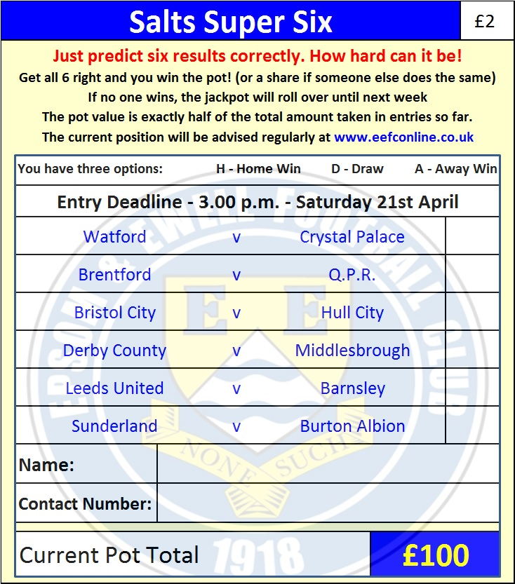

Good luck!

Combined Counties League – Premier Division
Tuesday, 17th April 2018 - Kick-off 7.45 p.m.
Epsom and Ewell  (Royal Blue & White hoops) | V |  | CB Hounslow United  (All Grey)
Squad | NUMBERS |  | Squad
Conor Young |  |  | Alex Wines
Endrit Dobraj |  |  | Rhys Forster
Shaun Masterson |  |  | Stuart Bamford
Adam Heagney |  |  | Adam Roberts
© Alex McKay |  |  | Harry Driver ©
Ashley Thompson |  |  | Chris Henry
Marlon Pinder |  |  | Tommy O’Neill
Scott Murphy |  |  | Merko Christo
Kyen Nicholas |  |  | Sirak Beyene
Elliott Thompson |  |  | Dunnel King
Ben Dyson |  |  | Harrison Livingstone
Lloyd Connelly |  |  | Jack Watts
Liam Roberts |  |  | Gavin Bamford
Miguel Anderson |  |  | Gabriel Chiedozie
Ben Franklin |  |  | Jordan Ireland
Reisse Griffin |  |  | Oliver Wright
Stuart Russell |  |  | Billy Roach
Jordan Clark |  |  | Thomas Kanek
Alvin MacAuley |  |  | Jordan Vidal
Rory Sellick |  |  | Shakeel Morris
Germaine Jeannoel
Joshua Caulcrick
Neil Grant | MANAGER |  | Barry Chapman
Alex McKay | ASSISTANT |  | Gavin Bamford
 | COACH / PHYSIO |  | Pete Morris / Alfie Chapman
REFEREE: P.Georgiou
ASSISTANTS: R.Wells, J.Lidbetter

OUR NEXT VISITORS TO HIGH ROAD
AFC Hayes
Cherry Red Combined Counties League – Premier Division
Saturday 28th April 2018 – 3.00 p.m.

